**Annual Spring 2025**

**Hanging Basket Fundraiser**

*Locally Grown By The Garden Factory*

**Please email the completed form to Sydney Martell at** [**SMartell@gardenfactoryny.com**](mailto:SMartell@gardenfactoryny.com)

**Order by May 9th for pick up or delivery by May 23rd.**

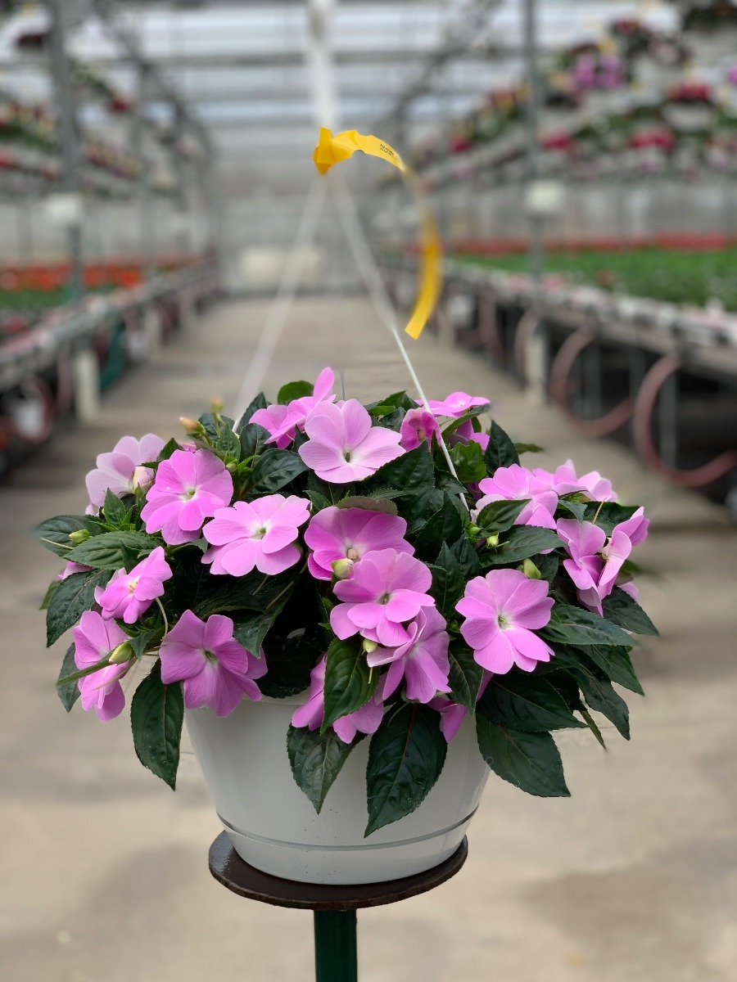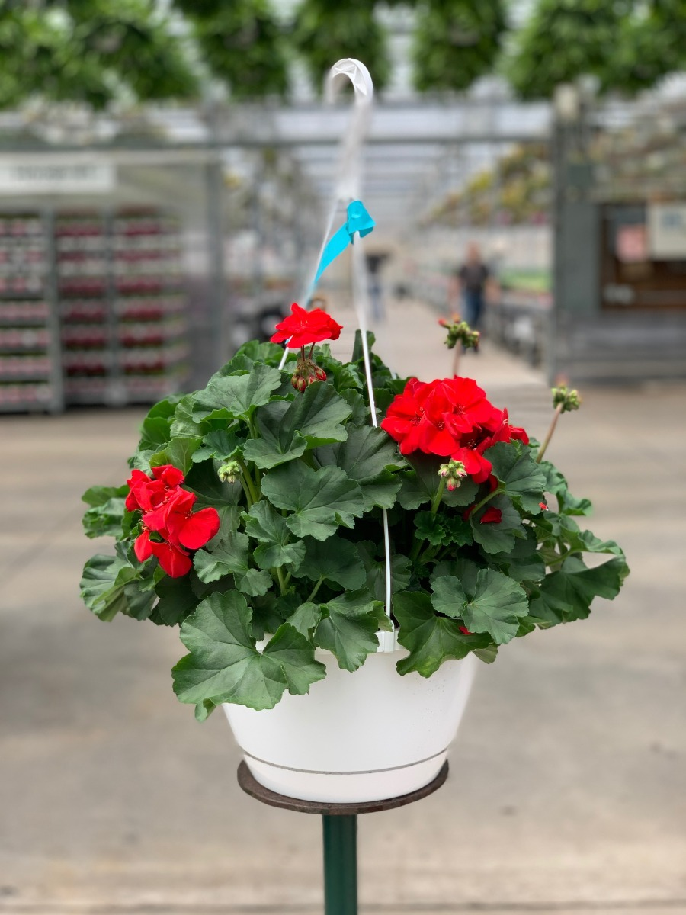**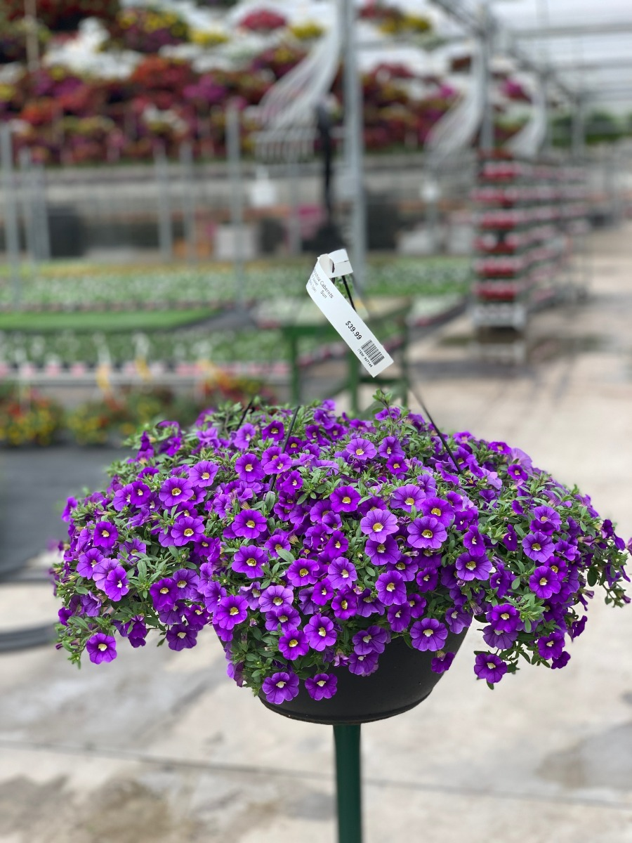Delivery is available for orders. Delivery fee based on zipcode.**

Calibrachoa Geranium New Guinea Impatiens Wave Petunia Part Sun

*All 10” Hanging Baskets. Assorted Colors.

|  |  |  |  |
| --- | --- | --- | --- |
| **HANGING BASKET TYPE** | **Suggested Retail** | **QTY** | **TOTAL $** |
| Calibrachoa | $24.99-$29.99 |  |  |
| Geranium | $24.99-$29.99 |  |  |
| New Guinea Impateins | $24.99-$29.99 |  |  |
| Wave Petunia | $15.99-$19.99 |  |  |
|  | TOTAL |  |  |

Name of Purchaser______________________________________________________________

Address_________________________________________________________________________

Phone_______________________Email______________________________________________

Group Order Name/Company_____________________________________________________

Group Main Contact______________________________________________________________

Group Main Contact Phone & Email________________________________________________

Group or Delivery Address____________________________________________________

Card #:____________________________________Exp.:__________Code:____________

Date:_______Signature:_______________________________Total:$________________